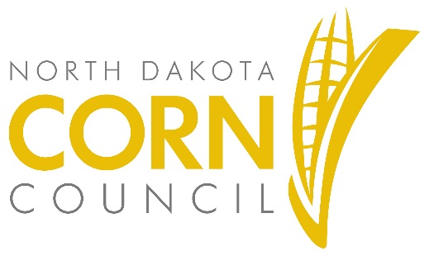
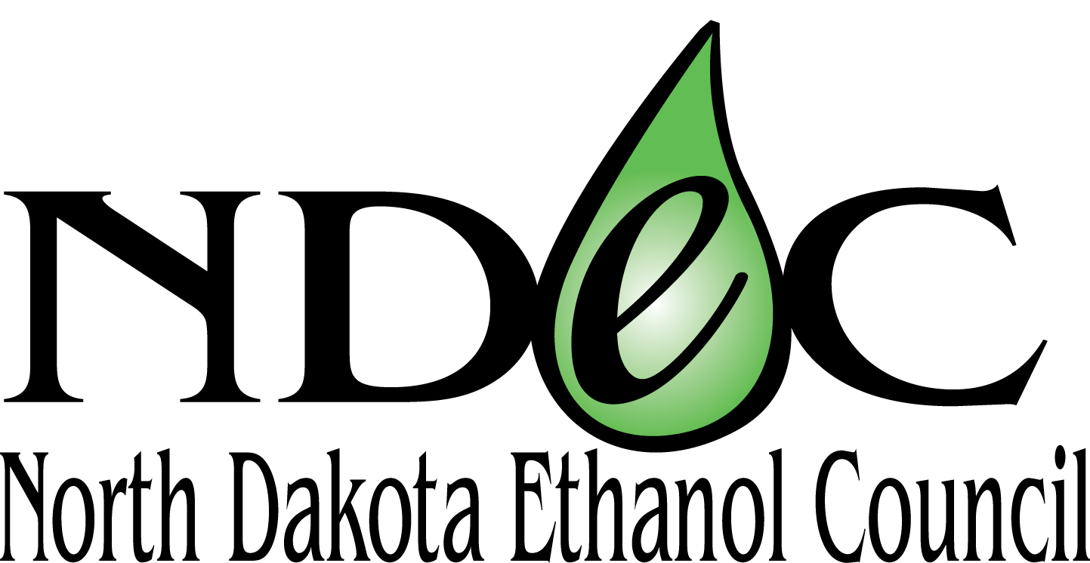

FOR IMMEDIATE RELEASE

CONTACT:
Heidie Haugo, Communications Director
701.566.9327 | heidie@ndcorn.org

North Dakota Corn and Ethanol Industries Partner with Fuel Retailers
to offer Unleaded88, a Safe, Economical, Cleaner Fuel Option

FARGO, North Dakota — Sept. 15, 2019 — The North Dakota Corn Utilization Council, in coordination with the North Dakota Ethanol Council, is implementing the North Dakota Unleaded88 Expansion Program. The program’s goal is to partner with fuel retailers to provide drivers with Unleaded88, a higher-octane fuel containing 15 percent ethanol and 85 percent gasoline. Matching grant dollars from the North Dakota Corn Utilization Council will be available through June 30, 2020, to fuel retailers for infrastructure necessary to offer Unleaded88.
Unleaded88 provides a safe, economical, cleaner fuel option for consumers. It is government approved for all conventional light-duty vehicles, model 2001 and newer. These vehicles make up 90 percent of the light-duty vehicles on the road today.
“North Dakota’s five ethanol plants purchase 40-60 percent of the state’s corn crop annually providing a significant value-added market opportunity for North Dakota’s agricultural producers,” says Terry Wehlander, chairman of the North Dakota Corn Utilization Council. “Expanding the availability of Unleaded88 creates more market stability when the agriculture industry is struggling with a number of significant uncertainties.”
“Offering Unleaded88 at additional fuel retail stations across the state is beneficial for consumers and our rural communities,” says Jeff Zueger, chairman of the North Dakota Ethanol Council. “We look forward to working with the state’s fuel retailers and the Corn Council on this important program.”
The program guidelines provide that funds be awarded to fuel retailers on a first-come-first-serve basis and can be used for dispensers, piping, hardware and signage for distribution of ethanol blends of Unleaded88 or higher. After receiving the grant, retailers will be required to offer Unleaded88 for a minimum of 24 months. With the assistance of the North Dakota Corn Utilization Council and the North Dakota Ethanol Council, retailers will carry out marketing programs to further promote the use of Unleaded88 or higher ethanol blends.
“It is our hope this program be mutually beneficial for our North Dakota fuel retailers, consumers, and farmers.” says Jean Henning, North Dakota Corn Utilization Council Executive Director. “We are looking forward to a positive response from retailers and prompt development of the Unleaded88 infrastructure statewide.”
A list of current North Dakota E15 stations is available here.
###
NOTE TO EDITORS – North Dakota Unleaded88 Expansion Program Guidelines and Application are available at www.ndcorn.org or www.ndethanol.org. The application can be submitted via email to jean@ndcorn.org and by mail to ND Corn Utilization Council, 4852 Rocking Horse Circle S, Fargo, ND 58104. Contact Jean at 701-566-9322 or Deana at 701-355-4458 with questions specific to the program.

